Newaygo County Mental Health
Minutes of the Regular Meeting
February 14, 2017
10:00 a.m.

Call to Order/Welcome/Prayer
The regular monthly meeting of the Board of Directors of Newaygo County Mental Health was called to order by Madam Chairman Taube at 10:00 a.m. on Tuesday, February 14, 2017, in the Board Conference Room.

Member Hansen opened the meeting with prayer.

Roll Call

Members Present: Ralph Bell, Sarah Boluyt, Mike Hamm, Adele Hansen, Steve Johnson, Bryan Kolk, Todd Koopmans, Catherine Kellerman, Al Steil and Helen Taube

Members Excused: Kathy Broome and Marilyn Snell

Others Present: Michael Geoghan, Director, and Shannon Woodside, Recording Secretary, Carol Mills and Andrea Fletcher

Communications from the Public
No communications from the public.

Approval of Agenda
Motion by Member Steil, supported by Member Koopmans, to amend the agenda to include 8.2
Stan Nieboer’s resignation and 8.3 Marilyn Snell’s resignation. Motion carried
unanimously.

Approval of Minutes
Motion by Member Boluyt, supported by Member Johnson to approve the minutes of January 10,
2017, as presented in 6.0. Motion carried unanimously.

Presentation
Andrea Fletcher, Quality Improvement/Corporate Compliance Coordinator, presented on Quality Improvement Plan 2017-2018 and Annual Customer Satisfaction Survey. Review and discussion took place.

Motion by Member Boluyt, supported by Member Steil, to approve the Quality Improvement Plan 2017-2018 as presented in 7.1. A roll call vote took place.

Ayes: Bell, Boluyt, Hamm, Hansen, Johnson, Kellerman, Kolk, Koopmans, Steil, Taube
Nays: None

Motion carried, 10 – 0.
Director’s Update
Director Geoghan reviewed his written report presented in 8.0 and asked the Board of Director’s to approve Agency Goals 2017-2018, Michael Hamm’s reappointment to MSHN’s Board of Directors, resignations of Stan Nieboer and Marilyn Snell. The Newaygo County Board of Director’s have 3 open positions due to Marilyn Snell’s resignation. Review and discussion took place.

Motion by Member Kellerman, supported by Member Boluyt, to approve Newaygo County Mental Health Agency Goals 2017-2018 as presented. A roll call vote was taken.

Ayes: Bell, Boluyt, Hamm, Hansen, Johnson, Kellerman, Kolk, Koopmans, Steil, Taube
Nays: None

Motion carried, 10 – 0.

Motion by Member Koopmans, supported by Member Bell, to approve reappointing Michael Hamm to the Mid-State Health Network Board of Director’s. A roll call vote was taken.

Ayes: Bell, Boluyt, Hamm, Hansen, Johnson, Kellerman, Kolk, Koopmans, Steil, Taube
Nays: None

Motion carried, 10 – 0.

Motion by Member Steil, supported by Member Boluyt, to accept Marilyn Snell’s resignation from Newaygo County Board of Directors, effective immediately. A roll call vote was taken.

Ayes: Bell, Boluyt, Hamm, Hansen, Johnson, Kellerman, Kolk, Koopmans, Steil, Taube
Nays: None

Motion carried, 10 – 0.

Motion by Member Steil, supported by Member Hamm, to approve Stan Nieboer’s resignation from Newaygo County Board of Director’s effective December 31, 2014. A roll call vote was taken.

Ayes: Bell, Boluyt, Hamm, Hansen, Johnson, Kellerman, Kolk, Koopmans, Steil, Taube
Nays: None

Motion carried, 10 – 0.

Executive Committee
Minutes of February 1, 2017 were reviewed and discussed.

Motion by Member Koopmans, supported by Member Steil to accept the quarterly positive review of the annual goals of the Executive Director. A roll call vote was taken.

Ayes: Bell, Boluyt, Hamm, Hansen, Johnson, Kellerman, Kolk, Koopmans, Steil, Taube
Nays: None
Motion carried, 10 – 0.

Finance Committee
Check Register and Cash Statement were reviewed with the following inquiries addressed by Carol Mills.

Check Register

89268 No name $15,270.02; This amount is for multiple hospital
stays.
89288 Stuart Wilson $5,980.00; This amount is for two months of fees for
our fiscal intermediary.
89396 The Right Door $8,490.00; This amount is for our psychiatrist.
89397 Dr. Liu $6,799.80; This amount is for our child psychologist.
89407 Unemployment Insurance Agency $4,930.64; This amount is for reimbursing the state
for actual cost.

Cash Statement
Compensated Absence CD – as of the last day of the fiscal year, staff vacation is added up and figure out what that value is and set it aside.

Policy Committee
Member Hamm reported on the meeting of January 19, 2017, where the following policies, procedures and forms were reviewed and discussed. Member Hamm recommended to vote separately on policy 1.BOD.120. Travel Reimbursement – Board Member Conference/Training.

1BOD101 | POLICY MANUAL - POLICY | No change
1BOD102 | AGENCY PHILOSOPHY AND MISSION STATEMENT | No change
1BOD103 | DEFINITION AND DESCRIPTION OF SERVICE AREA | No change
1BOD104 | BYLAWS | No change
F11104.1 | RESPONSIBILITIES OF A NEWAYGO COUNTY MENTAL HEALTH BOARD EMBER & COMMITMENT TO SERVE | No change
1.BOD105 | INVESTMENT- POLICY | No change
1.BOD105A | INVESTMENT- PROCEDURE | REVISED
F1105.1 | ACKNOWLEDGEMENT & RECEIPT OF INVESTMENT POLICY AND AGREEMENT TO COMPLY | No change
1.BOD106 | COMMITTEE STRUCTURE - POLICY | No change
1.BOD107 | TEMPORARY REPLACEMENT OF THE EXECUTIVE DIRECTOR - POLICY | No change
1.BOD107A | TEMPORARY REPLACEMENT OF THE EXECUTIVE DIRECTOR - PROCEDURE | No change
1.BOD108 | RECRUITMENT/REPLACEMENT OF THE EXECUTIVE DIRECTOR - POLICY | No change
1.BOD108A | RECRUITMENT/REPLACEMENT OF THE EXECUTIVE DIRECTOR - PROCEDURE | No change
1.BOD109 | EXECUTIVE DIRECTOR COMPENSATION | No change
1.BOD114 | BOARD/EXECUTIVE DIRECTOR RELATIONSHIPS | No change
1.BOD115 | ANNUAL EVALUATION OF THE EXECUTIVE DIRECTOR - POLICY | No change
1.BOD115A | ANNUAL EVALUATION OF THE EXECUTIVE DIRECTOR - PROCEDURE | No change
1BOD116 | ASSISGNMENT OF LIAISON WITH THE COUNTY BOARD OF COMMISSIONERS - POLICY | No change
1BOD116A | ASSIGNMENT OF LIAISON WITH THE COUNTY BOARD OF COMMISSIONERS - PROCEDURE | No change
1BOD117 | CURRENT BOARD MEMBERSHIP | REVISED
1BOD117A | BOARD ORGANIZATIONAL CHART | No change
1BOD118 | COMMUNICATIONS | No change
1BOD119 | BOARD MEMBER ORIENTATION | No change
1BOD120 | TRAVEL REIMBURSEMENT – BOARD MEMBER CONFERENCE/TRAINING | REVISED
F1120.1 | BOARD MEMBER EXPENSE VOUCHER | No change
1BOD121 | BOARD AGENDA | No change
1BOD122 | INSURANCE - LIABILITY | No change
1BOD123 | FIXED ASSETS AND INVENTORY CONTROL | No change
1BOD124 | CONFLICT OF INTEREST - POLICY | No change
1BOD124A | CONFLICT OF INTEREST - PROCEDURE | No change
1BOD125 | ACCREDITING AGENCIES – POLICY | No change
1BOD125A | ACCREDITING AGENCIES – PROCEDURE | No change
1BOD126 | COMPLIANCE PLAN | No change
F1126.1 | COMPLIANCE PLAN EVALUATION TOOL | No change
F1126.2 | COMPLIANCE PROGRAM ACKNOWLEDGEMENT | No change
1BOD127 | COMPLIANCE REPORTING, CONFIDENTIALITY, AND NON-RETALIATION - POLICY | No change
F1127.1 | REPORT OF SUSUPECTED VIOLATIONS AND MISCONDUCT | No change
F1127.2 | ACKNOWLEDGEMENT OF RECEIPT/REPORT OF SUSPECTED COMPLIANCE VIOLATION OR MISCONDUCT | No change
1BOD127A | COMPLIANCE REPORTING, CONFIDENTIALITY, AND NON-RETALIATION - PROCEDURE | No change
1BOD128 | COMPLIANCE INVESTIGATION, RESOLUTION, AND DOCUMENTATION PROCEDURE | No change
1BOD129 | OPEN MEETINGS | No change
1BOD130 | INTERNAL CONTROLS | No change
1BOD131 | ETHICAL BEHAVIOR – POLICY | REVISED
1BOD131A | ETHICAL BEHAVIOR – PROCEDURE | No change
1BOD132 | ANNUAL REPORT/INFORMATION - POLICY | No change
1BOD132A | ANNUAL REPORT/INFORMATION – PROCEDURE | No change
1BOD133 | STATEMENTS TO THE PRESS & ELECTRONIC MEDIA – POLICY | No change
1BOD133A | STATEMENTS TO THE PRESS & ELECTRONIC MEDIA - PROCEDURE | No change
1BOD135 | BUILDING FACILITY USAGE – OUTSIDE GROUPS – POLICY | No change
1BOD135A | BUILDING FACILITY USAGE – OUTSIDE GROUPS – PROCEDURE | No change
F1135.1 | FACILITY USE PERMIT APPLICATION | No change
1BOD136 | BEHAVIORAL HEALTH PROMOTION – COMMUNITY EDUCATION & INVOLVEMENT – POLICY | No change
1BOD136A | BEHAVIORIAL HEALTH PROMOTION – COMMUNITY EDUCATION & INVOLVEMENT – PROCEDURE | No change
1BOD137 | BOARD DEVELOPMENT | No change
F1137.1 | BOARD SELF-ASSESSMENT | No change
F1137.2 | ASSESSMENT OF FULL BOARD FUNCTIONING | No change
F1137.3 | INDIVIDUAL BOARD MEMBER SELF-ASSESSMENT GOVERNANCE COMPETENCIES | No change
1BOD138 | CONFLICT OF INTEREST – MID-STATE HEALTH NETWORK - POLICY | No change
1BOD138A | CONFLICT OF INTEREST – MID-STATE HEALTH NETWORK –PROCEDURE | No change
1BOD139 | SELECTION OF MEMBERS OF THE MSHN CONSUMER ADVISORY COUNCIL | REVISED
1BOD140 | RECRUITMENT OF NEW BOARD MEMBERS – POLICY | No change
1BOD140A | RECRUITMENT OF NEW BOARD MEMBERS - PROCEDURE | No change
Motion by Member Boluyt, supported by Member Kellerman, to approve the above-listed policies, procedures, and forms as presented, with the exception of 1.BOD.120 Travel Reimbursement – Board Member Conference/Training. A roll call vote was taken.

Ayes: Bell, Boluyt, Hamm, Hansen, Johnson, Kellerman, Kolk, Koopmans, Steil, Taube
Nays: None

Motion carried, 10 – 0.

Motion by Member Steil, supported by Member Kellerman to approve the policy 1.BOD.120 Travel Reimbursement – Board Member Conference/Training with the recommended changes, with the exception of tipping, keep tips at 20% as stated in policy, instead of the recommended change of 15%. A roll call vote was taken.

Ayes: Hamm, Hansen, Johnson, Kellerman, Steil, Taube
Nays: Bell, Boluyt, Kolk, Koopmans

Motion carried, 6 – 4.

Recipient Rights Committee
Member Koopmans reported on the meeting of February 13, 2017, where the following policies, procedures and forms were reviewed and discussed.
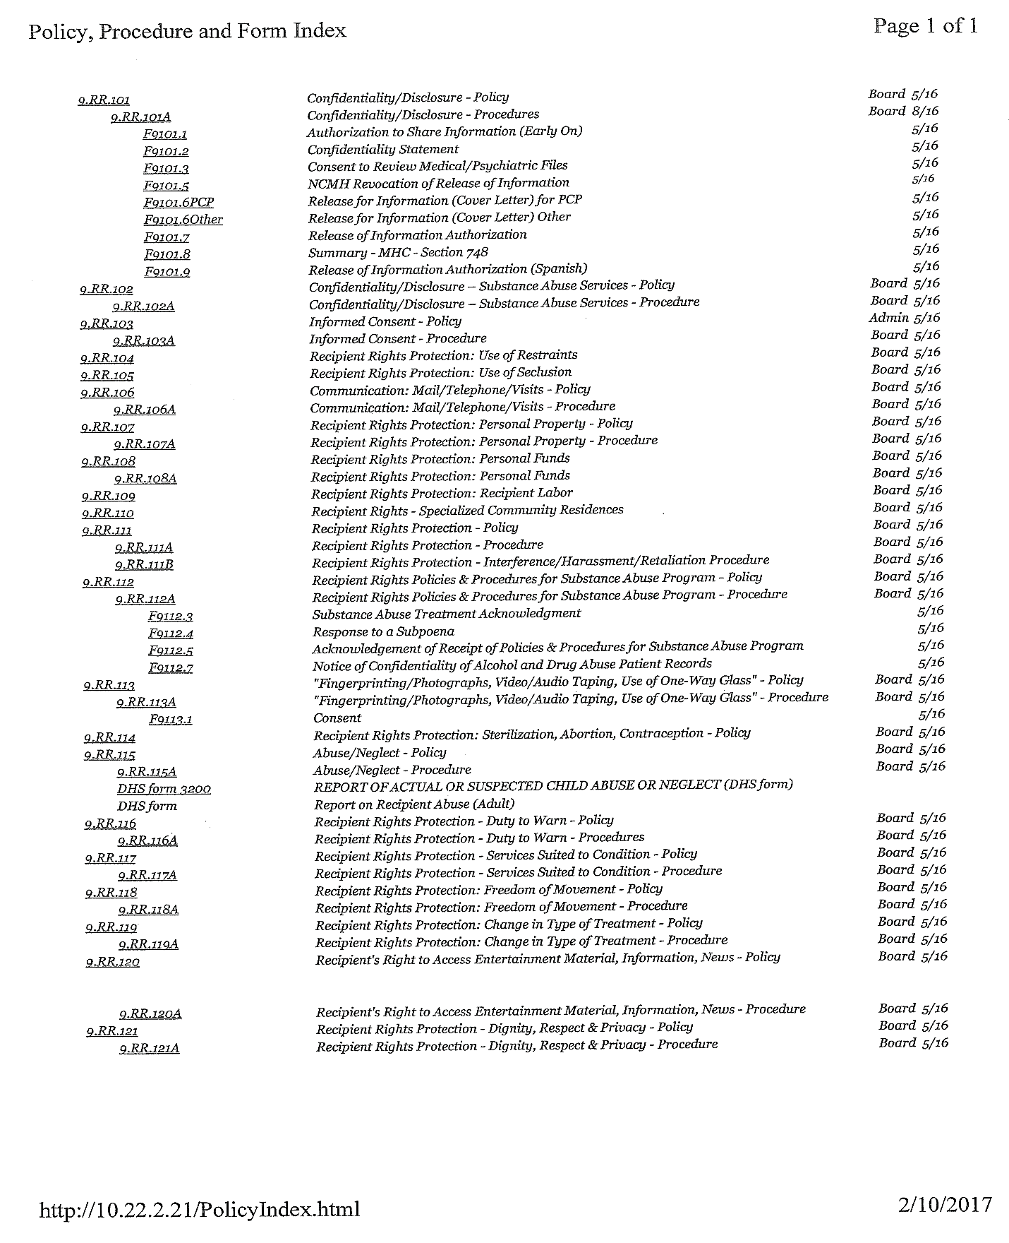

Motion by Member Kellerman, supported by Member Bell, to approve the above-listed policies, procedures, and forms as presented. A roll call vote was taken.

Ayes: Bell, Boluyt, Hamm, Hansen, Johnson, Kellerman, Kolk, Koopmans, Steil, Taube
Nays: None

Motion carried, 10 – 0.

The next Recipient Rights Committee meeting and training is May 8, 2017 at 10:00 a.m.

Promotion & Education Committee
The next Promotion & Education Committee meeting is February 22, 2017 at 2:00 p.m.

Consumer Advisory Committee
Member Kellerman reported on the meeting of January 26, 2017. Consumer Advisory Committee meeting is scheduled for January 26, 2017 at 1:00 p.m.

Mid-State Health Network
Member Hamm shared that the next meeting is March 7, 2017 at 5:00 p.m.

MACMHB
Highlights of the winter conference.
- COO Carol Mills presentation was fantastic.
- Grant from Health Endowment, Senior Reach program
- MI Child Health Insurance Program

Other
Member Bell shared that Empowerment Network has set the Annual Fishing schedule, fourth Tuesday of the month, 11:00 a.m. at Fremont Lake.
- May 23
- June 27
- July 25
- August 22 and picnic

Communications from the Public
There was no public comment.

Adjournment
Motion by Member Boluyt, supported by Member Steil, to adjourn the meeting at 12:06 p.m. Motion carried unanimously.

Helen Taube, Chairperson Catherine Kellerman, Secretary

